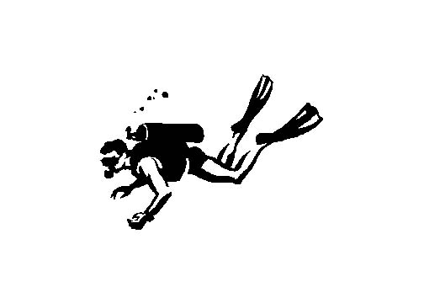

Name:

**The Dive Lab**

**Learning Target**: Develop a lab procedure to test and explain the effects of cold water submersion and holding breath have on heart rate.

The nervous system regulates all organs to help the body maintain homeostasis. You will be testing how the nervous system responds to different environments by measuring changes in heart rate. You will be using an EKG (ECG – electrocardiogram) sensor to monitor heart rate through the computer.

**Day 1**: Practice without water, properly use equipment, interpret data (hardest part!)on an EKG. Test different situations where you know your heart rate is going to change – resting, standing, lying down, running etc. From your trials learn how to interpret the data

Develop your lab (actually walk yourself through the lab to make sure you covered all of your bases)

**Day 2**: Carry out lab, analyze data and share

**Guidelines:**-water should be between 5-10o C

-use the same positions for each trial

-water should go only to the hairline

-run multiple trials

-you will need **controlled data** to compare your trials to

**Hypothesis: (if/then)** Be sure that your hypothesis clearly relates to the problem, procedure, variables and ***nervous system.***

**Identify your variables:**

Independent: (measured w/units)

Dependent: (measured w/units)

Controls: (must have at least 3)

**Procedure:**

**Teacher approval___________________________**

**Vernier directions**

1. Connect and plug in EKG sensor and golink.
2. Open Logger Pro from Zenworks
3. Your computer should recognize the software
4. Click on the yellow open folder.
5. From “Experiments” click “Probes & Sensors”
6. Select “ EKG Sensor”
7. Select “EKG and Heart Rate”
8. Wash and DRY areas on arms where electrodes will attach (see Figure 3)
9. Attach 3 electrode tabs to the arms of the test subject, as shown in Figure 3. Connect the leads of the EKG sensor test to the electrode tabs as shown in Figure 3.
10. Have the test subject sit in a relaxed position in a chair. The forearms should rest on the legs or arms of a chair. When the subject is properly positioned, have someone click “Collect” to begin data collection.
11. Once data collection is finished save trial and start a new graph. Do not run multiple trials on the same graph.

**Questions:**

1. Read the article on the mammalian dive reflex supplied by your instructor and then answer the following question:

a. How does the nervous system make the mammalian dive reflex possible? What is the purpose of the physiological changes?

Mammalian Dive Reflex Information

The purpose of this lab is to simulate the human physiological response to conditions that stimulate underwater diving. This constellation of responses has been termed the diving reflex and can be observed in many vertebrates. It is most pronounced in marine and aquatic mammals such as cetaceans (whales and dolphins), sirenians (manatees), some carnivores (seals, walrus, and otters), and rodents (beaver). The most dramatic components of the diving reflex are **reduced** heart rate (**bradycardia**) which is controlled by the parasympathetic nervous system and **increased** blood pressure due to peripheral vasoconstriction controlled by the sympathetic nervous system. The adaptive value of the diving reflex centers on the conservation of both oxygen and energy by reducing the energetically costly aerobic activity of the heart. Moreover, peripheral vasoconstriction shunts blood away from the extremities to the body’s core, thereby conserving core temperature.

The diving reflex in mammals is controlled, in part, by receptors of the trigeminal nerve (cranial nerve V) in the face, nose, mouth, which respond to the temperature of the water. Also, the vagus nerve (cranial nerve X) helps regulate heart activity (page 250 in your book discusses the 12 cranial nerves and their functions in greater detail). In diving mammals and humans as well, the stimulation of the trigeminal cold receptors in the nasal and phyarangeal passages results in apnea (cessation of breathing). In fact, approximately 30% of human drowning victims do not have water in their lungs because this powerful reflex prevents breathing.

A St. Helen fisherman survived after spending 30-45 minutes in the icy waters of Houghton Lake in Michigan on 12/13/2003 (Houghton Lake Resorter 12/24/03). How can someone survive without breathing for greater than 30 minutes? We hypothesize that the Mammalian Dive Reflex (MDR) is an adaptation for surviving cold-water submergence that allows for this phenomenon. Although the immediate response of a fall into cold-water is a sympathetic nervous system releasing adrenaline to initiate the “fight or flight” response, the MDR is a parasympathetic, or “rest and digest” response, that overcomes this initial increase in metabolic activity. Bradycardia (decreased heart rate) and peripheral vasoconstriction work in conjuction to conserve body heat and blood oxygen, preventing brain and vital organ damage. Another characteristic of MDR is decreased ability to hold one’s breath, allowing for faster initiation of the parasympathetic response and thus maximum retention of oxygen. Previous studies indicate that submerging the face in icy water for 30 seconds will induce MDR. If MDR is an adaptation for surviving cold-water submersion, then test subjects should exhibit MDR (bradycardia, peripheral vasoconstriction, and decreased breath holding ability) after facial submergence in icy water.