…CRUNCH……“OOOOOOWWWWWEEEEE! That hurt!” Name:____________________
The Master Guide To Fractures
Learning Target: Research and create a model to accurately depict the 10 fracture types and how they occur.
Fractures to be modeled:
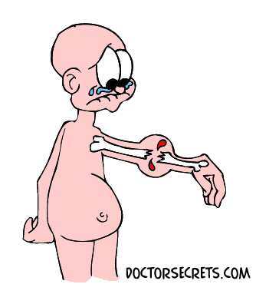
  - Depressed
  - Transverse
  - Comminuted
  - Oblique
  - Epiphyseal
  - Spiral
  - Greenstick
  - Avulsion
  - Impacted
  - Stress Fracture

For each fracture you must include the following:
1. Model of each fracture (must be 3-D) (2 pts)
Proficient: 3-D, clear fracture line, accurately represents fracture type, visually appealing
2. Scenario/Situation for each fracture (4 pts)
- Scenario/situation is clearly explained or displayed and is appropriate for fracture type
- Explain the type of force commonly applied to cause the fracture
- Appropriate location (bone) for fracture given and correlates with scenario/situation

 | Model | Force | Common Location | Situation/  scenario
Fracture Type | 2 pts | 1 pt | 1 pt | 2 pts
- Depressed
- Transverse
- Comminuted
- Oblique
- Epiphyseal
- Spiral
- Greenstick
- Avulsion
- Impacted
- Stress Fracture
Totals | /20 | /10 | /10 | /20
Final Score _________/2 = _________/30 points

