Name:________________________
Skin Homeostatic Imbalances: when homeostasis is no longer maintained and results in a condition/disease or disorder of the skin.
Learning Targets:
- Identify and describe several homeostatic imbalances of the skin (athlete’s foot, boils and carbuncles, cold sores, contact dermatitis, impetigo, psoriasis).
- Differentiate between 1st, 2nd and 3rd degree burns.

Directions:
- Use the internet to answer the following questions regarding homeostatic imbalances of the skin.
- Burns: Severity of burns are classified by depth. Knowing this explain what layers of the skin are damaged for the following types of burns:
  - 1st Degree:
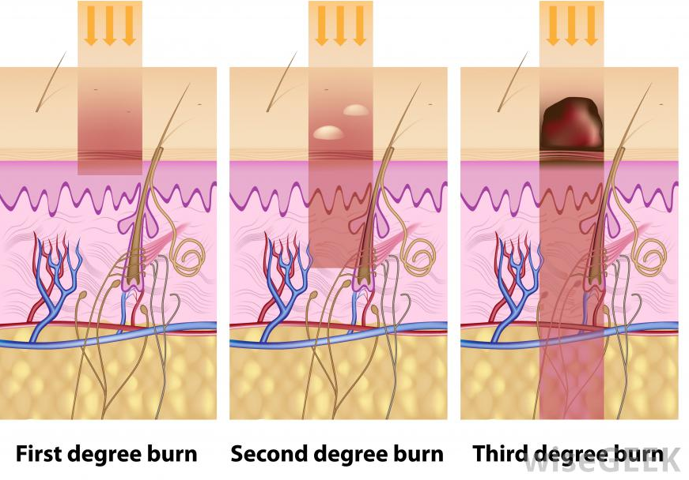
    - Signs/symptoms:
    - Treatment:
  - 2nd Degree:
    - Signs/symptoms:
    - Treatment:

  - 3rd Degree:
    - Signs/symptoms:
    - Treatment:

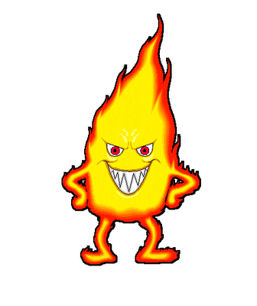
Burn…Burn…Burn
- Click on the following link to complete the case study:

http://wps.aw.com/bc_marieb_happlace_7_oa/42/10965/2807112.cw/
- Left side – select “case studies” – select chapter 5 “BURNS”

- Once finished you must show your teacher this final page showing completion!
- Explain how having a severe burn can affect multiple body systems. Use examples from the activity.

- In summary, what treatments did you administer throughout the course of Juan’s burn recovery and what was the purpose of these treatments?

- Athlete’s Foot:
  - Caused by:
  - Signs/symptoms of condition:
  - Find a picture and describe what it looks like (remember google images will give you probably the worst case scenario):

- Boils and Carbuncles:
  - Caused by:
  - Signs/symptoms of condition:
  - Where is this usually located on the body:
  - Find a picture and describe what it looks like (remember google images will give you probably the worst case scenario):
- Cold Sores:
  - Caused by:
  - Signs/symptoms of condition:
  - Where is this usually located on the body:
  - Find a picture and describe what it looks like (remember google images will give you probably the worst case scenario):
- Contact Dermatitis:
  - Caused by:
  - Signs/symptoms of condition:
  - Find a picture and describe what it looks like (remember google images will give you probably the worst case scenario):
- Impetigo:
  - Caused by:
  - Signs/symptoms of condition:
  - Where is this usually located on the body:
  - Find a picture and describe what it looks like (remember google images will give you probably the worst case scenario):
- Psoriasis:
  - Caused by:
  - Signs/symptoms of condition:
  - Find a picture and describe what it looks like (remember google images will give you probably the worst case scenario):

