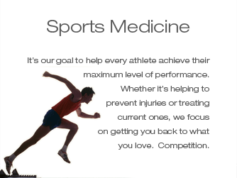
Unit 1: Introduction to Sports Medicine

Enduring Understanding
Sports medicine involves a variety of professions that use common terminology and an organized hierarchy to allow for appropriate response and treatment in an emergency or injury situation

Learning Targets
- Explain the goal of sports medicine and what professions fall under the sports medicine umbrella

- Apply basic terminology used in the area of sports medicine to discuss a sports related injury, location on the body or communicate with the medical community (ongoing learning target)

- Appropriately respond in an emergency situation and provide basic injury assessment
*(Students are not certified to give medical care to anyone. This is to develop a better understanding of the sports medicine field and would require higher education to provide care.)

- Explain how environmental conditions play a role in sports performance and explain how to treat these conditions

- Explain the “Good Samaritan Laws” and how they apply to responding to emergency situations

- Explain what H.I.P.A.A. compliance is and why it was put into place

Vocabulary

Sports medicine
Athletic training
Hypothermia
Hyperthermia
Frost bite
Heat Stroke
H.O.P.S.
C.P.R.
A.E.D.
Primary survey
Secondary survey
P.R.I.C.E
Good Samaritan Laws
H.I.P.A.A.

Anatomical position
Frontal
Transverse
Sagittal
Midsagittal

Anterior/posterior
Proximal/distal
Superficial/deep
Medial/lateral
Superior/inferior
Intermediate

Abduction/adduction
Dorsiflexion/plantar flexion
Circumduction
Rotation
Supination/pronation
Opposition
Hyperextension
Extension/flexion
Eversion/Inversion

