Unit 1 Review Name:______________________
- Using the diagram insert arrows and label them with the following terms:
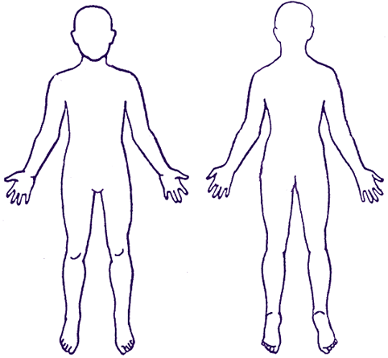
  - Superior
  - Inferior
  - Lateral
  - Distal
  - Medial
  - Intermediate
  - Proximal

- Write an example on the human body to show the difference between the following:
  - Superficial

  - Deep
  - Anterior
  - Posterior
- Using the diagram draw lines and label the following planes of the human body:
  - Transverse
  - Sagittal
  - Midsagittal
  - Frontal

- Draw a person in the following position
  - Abducted arm (one arm)
  - Hyperextended neck
  - Flexed knee (one leg)
  - Circumducted leg and displaying plantar flexion (other leg)
  - Rotated and showing opposition (other arm)

- Write a statement describing sports medicine that encompasses all of the professions that fall under the sports medicine profession :

- Using the scenario from below create a flowchart showing the steps you would take to respond to the athletes. Your flowchart must include arrows indicating direction and appropriate vocabulary. Be specific. See example below if necessary.
  - During a basketball game two players collide when going for a loose ball. They both fall to the ground. One player is grabbing his elbow writhing in pain and the other player is not breathing and unconscious. How do you respond to the two injured athletes?

- Give signs/symptoms and treatment for the following:
  - Shock

  - Heat exhaustion

  - Heat stroke
  - Hypothermia
  - Allergic reaction

