|  |  |  |
| --- | --- | --- |
| Thursday, September 11th | Basic Chem Notes /  Amazing Demos! / Water Notes |  |
| Friday, September 12th | Inorganic Notes finish / Blood Buffer Lab |  |
| Monday, September 15th | Blood Lab Disc. / Organic Notes |  |
| Tuesday, September 16th | Organic Notes / Catalase Lab |  |
| Wednesday, September 17th | Catalase Lab | Organic Cornell Notes Due |
| Thursday, September 18th | Catalase Lab Disc / Notes |  |
| Friday, September 19th | Molecule Sort / Lab Report Specifics / Review |  |
| Monday, September 22nd | Microscope Lab | Connect Review Due |

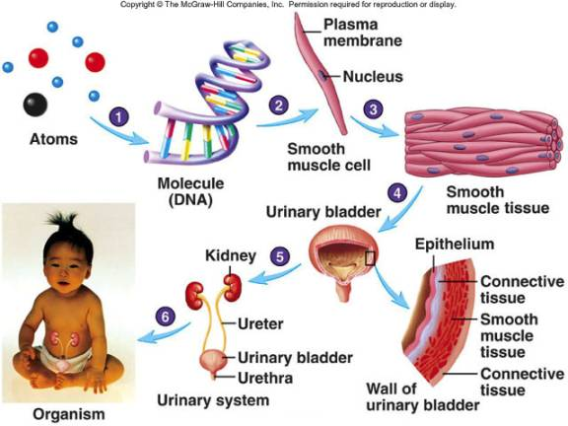

|  |  |  |
| --- | --- | --- |
| Tuesday, September 23rd | Microscope Lab | Lab Report Due |
| Wednesday, September 24th | Transport Notes / Walking Review | Transport Reading Due |
| Thursday, September 25th | Skit / Blood Lab |  |
| Friday, September 26th (1/2 day) | Protein Synthesis Notes / Protein Synthesis Concept Map |  |
| Monday, September 29th | Protein Synthesis Notes / Protein Synthesis Concept Map |  |
| Tuesday, September 30th | Review |  |
| Wednesday, October 1st | **Unit Test** | Connect Review Due |
| **https://vault.swri.org/cms/upload/cells_300pixels.jpg** | **http://www.meddean.luc.edu/lumen/MedEd/Histo/HistoImages/hl3A-48.jpg** | http://www.becomehealthynow.com/images/organs/nervous/nerve_cell1.jpg |