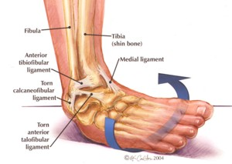
Unit 4: Common Injuries and Treatments of Ankle*

Enduring Understanding
Injuries are uniquely assessed, treated and rehabilitated based on the location of the body, cause of the injury and state of the injured person

Learning Targets
- Identify on a model or diagram the major parts of the ankle (see vocabulary list)

- Apply basic anatomy and physiology knowledge of the ankle to identify common injuries involved with sports and how they occur

- Model proper taping or bandaging techniques used in sports medicine to prevent and treat common sports injuries of the ankle

- Explain the trainer protocol for each injury and various techniques used to rehabilitate the injury

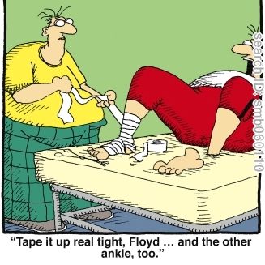
- Demonstrate and explain what you are trying to accomplish through the application of specific taping techniques

- Explain the major pre and post-taping considerations that need to be made when treating an injury

*Only to further understand the sports medicine field. Students should not tape themselves or others for treatment/rehabilitation unless further education is received

Vocabulary

Pre-wrap
Anchor
Heel Lock
Stirrups
Horseshoe

Talocrural joint
Tibia
Fibula
Medial malleolus
Lateral malleolus
Phalanges
-proximal phalanx
-middle phalanx
-distal phalanx

Metatarsals (I-V)
Tarsals
Calcaneus
Cuboid
Talus
Lateral Cuneiform
Intermediate Cuneiform
Medial Cuneiform
Navicular

Lateral (collateral) Ligaments
-Posterior talofibular ligament
-Calcaneofibular ligament
-Anterior talofibular ligament

Medial (deltoid) Ligaments
-Posterior tibiotalar ligament
-Tibiocalcaneal ligament
-Anterior tibiotalar ligament
-Tibionavicular ligament

Achilles (calcaneal) tendon

