Unit 6: Conditioning and Rehabilitation Programs

Enduring Understanding
The basic principles of conditioning and overload are used by sports medicine professionals to increase performance, rehabilitate and injury and/or prevent an injury

Topic: Conditioning of the Human Body

- Define flexibility, muscular strength, muscular endurance and muscular power; explain their role in injury prevention/rehabilitation

- Explain the different types of stretching and their role in injury prevention/rehabilitation

Topic: Rehabilitation Programs

- Understand various methods used for rehabilitation and the stages used when developing rehabilitation plans for specific sports related injuries

- Research and demonstrate rehabilitation or conditioning exercises for a specific injury and explain how the exercise helps the athlete recover from the injury

Vocabulary
Rehabilitation
Conditioning
I.M.P.R.E.S.S.
Progressive Resistance
Specificity
Overload Principle
Isometric Training
Isotonic Training
Isokinetic Training
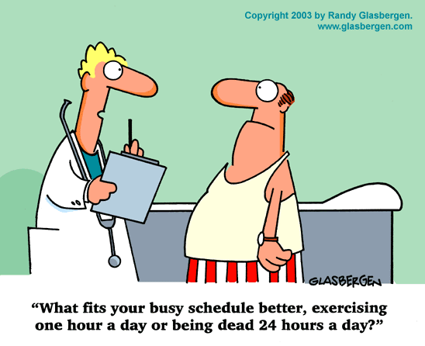
Muscular Strength
Muscular Endurance
Muscular Power
Muscular Flexibility
Static Stretching
Ballistic Stretching
Dynamic Stretching
Concentric
Eccentric

