Woolly Worm Lab

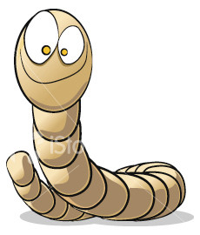

Name:___________________________

Objective: Simulate the process of natural selection.

1. You are a hungry bird and you will have 3 minutes to “hunt” for your food. The food is 3 inch long woolly worms distributed in a 40’x40’ area. You must pick at least 30 worms to be able to survive.
2. **Hypothesize**: Which worms will have the best chance of surviving your feast? Why?
3. After the time is up, bring the captured worms to your group and count up each color and fill in the data table below.
4. Graph: Using the class data, construct a graph showing the number of worms left after the attack for each color.

|  |  |  |  |  |  |  |  |  |
| --- | --- | --- | --- | --- | --- | --- | --- | --- |
| **Color of Woolly Worm** | **# Before Attack** | **# Captured by each individual** | | | | | **Total # Class Captured** | **# of Woolly Worms left after attack** |
|  | 100 |  |  |  |  |  |  |  |
|  | 100 |  |  |  |  |  |  |  |
|  | 100 |  |  |  |  |  |  |  |
|  | 100 |  |  |  |  |  |  |  |
|  | 100 |  |  |  |  |  |  |  |
|  | 100 |  |  |  |  |  |  |  |
|  | 100 |  |  |  |  |  |  |  |
|  | 100 |  |  |  |  |  |  |  |
|  | 100 |  |  |  |  |  |  |  |
|  | 100 |  |  |  |  |  |  |  |
|  | 100 |  |  |  |  |  |  |  |
|  | 100 |  |  |  |  |  |  |  |
|  | 100 |  |  |  |  |  |  |  |
|  | 100 |  |  |  |  |  |  |  |

Follow-up Questions

1. Was your hypothesis supported? Why or why not?
2. Hypothesize what would happen to the different colored worm populations if the birds were able to prey on the worms 5 more times.
3. What determines which genes in an organism will be an advantage or a disadvantage.
4. How does this lab simulate Darwin’s theory of natural selection? Discuss the 4 key principles to the theory of natural selection in your response.

